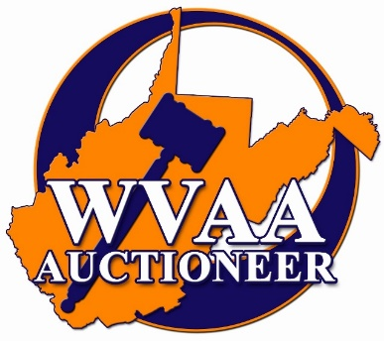

2023 Bid Calling Championship
Saturday, February 25th, 2023, at 6:00 p.m.

Name __________________________________________ WV License # _________

Bid Calling Competition $50 $_____________
Divisions:
Senior _____ Rookie ______
(Licensed 5 years or less)

WVAA Membership
Auctioneer Membership - $50 $_____________

Grand Total $___________

Contestants must be a current PAID West Virginia Auctioneers Association member
and must have attended the convention session on Friday or Saturday to be eligible
for competition. To renew or become a WVAA Member please fill out the information below:

Home Address ____________________________________________________________
Company Name ___________________________________________________________
Company Address__________________________________________________________
County ___________ Phone # _______________ Email Address ____________________
Date of Birth _______________ # of Years in Auction Profession ____________________
NAA Member (Yes or No) ______ Type of Auctions you conduct ___________________
Designations (please circle) CAI AARE GPPA Other ______________________________
Real Estate Agent _______ Salesperson _______ Broker
Do you hold license in other states? ___ States ___________________________________
**To be listed as a member on the WVAA website, you MUST have a full name, address, license number, phone number and e-mail address entry on this form. This is a requirement by our website provider.

Mail entry forms to: West Virginia Auctioneers Association C/O Ellie Saunders
399 W. Main St. Bridgeport WV 26330

Office Use Only:
Payment Cash __________ Check # ______________ $ ___________________
Credit Card # ______________________________ CVV# _____ Exp. Date ________ Zip_______ 5% Processing Fee.

